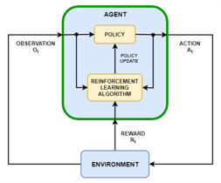

Environment States(s)
Agent
Action α
Policy

Policy Update
Reinforcement Learning Algorithm

Reward r

Environment

Reward r
Environment state(s)
Action α
Agent
Environment
Critic
Reward
Actor
Process
u
x
x
r
r
r
Approximating Function
$J_{k}(x_{k}, u_{k})$ction
Training Data
$J_{k}, x_{k}, k=1…N-1$ction $J(x)$
Target Cost Function 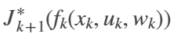
Approximation Architecture Parameter

